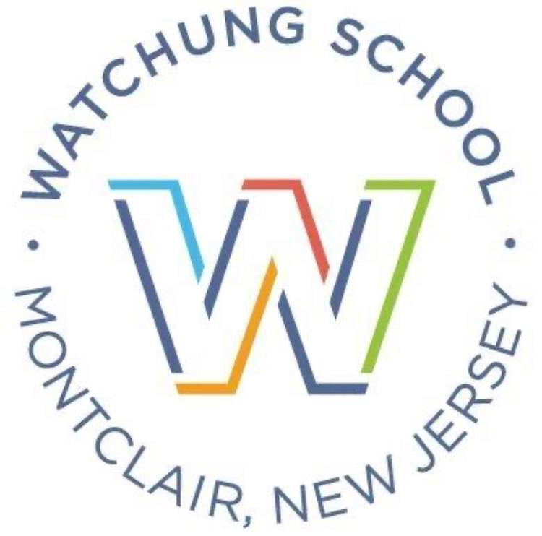

Watchung PTA
Today – Tomorrow – Forever
Your Student’s Watchung Legacy

Yes, we’d like to purchase a permanent brick! Please engrave our brick as follows:

ANY SYMBOL IS CONSIDERED ONE SPACE (PERIOD, COMMA, DASH, EXCLAMATION MARKS)
STANDARD PICTURE SYMBOLS (E.G. HEARTS) ARE ADDITIONAL $5.00 PER SYMBOL
ALL TEXT WILL BE CENTERED AND IN ALL CAPS UNLESS OTHERWISE NOTED
RECOMMENDED 3 LINES, 18 CHARACTERS PER LINE

4x8 Bricks @ $100.00 each = ____

4 x 8 Brick

EXAMPLE

I | A | N |  | M | C | L | A | U | G | H | L | I | N
C | L | A | S | S |  | O | F |  | 2 | 0 | 2 | 1
W | A | T | C | H | U | N | G |  | F | O | R | E | V | E | R | !

PLEASE RETURN THIS FORM TO Ralph Greco
VIA EMAIL RalphSGreco@gmail.com OR to Ms. Wolff’s Class
By Friday, June 16, 2023

NAME: ________________________________________

ADDRESS:__________________________________________________________________________

CITY:____________________________________ STATE: _____________ ZIP: __________________

EMAIL: ___________________________________________

AMOUNT PAID: ___________________ Via MemberHub or a check made out to Watchung PTA

If you have any questions, please contact Ralph Greco at ralphsgreco@gmail.com

